Name: Meratun Junnut Anee

Id:1620527043

**Title: Using UAV-Based Systems to Monitor Air Pollution in Areas with Poor Accessibility**

Publisher**: Hindawi**

Author: Oscar Alvear(1,2), Nicola Roberto Zema(3), Enrico Natalizio(3) and Carlos T. Calafate(1)

Date of publication: **7 August, 2017**

Review:

This paper mainly offers the benefits and accessibility of the use of UAVs equipped sensors to perform how to monitor air pollution. This paper is proposed with pollution driven UAV control algorithms, this idea is taken from chemotaxismataheuristicsand a local particle swarm optimization strategy. This system can perform automatically monitoring of specific area. Using this system firstly we can make a map of where pollution occurs, what are the pollutants and where the concentration of the pollutants is higher. It works faster and has a higher accuracy.

From this paper I received the message why we need to monitor the air at urban areas and cities as well. Why we need to be more careful on it. They had proposed crowdsensing solutions in monitoring pollution in urban areas.

This system has the safety and security concern where it is dangerous to access by human operators. They also consider their paper as commercial and off h Th e shelf devices and sensors.

They also showed **chemotaxi** based approach for UAV path control which achieves faster and more accurate estimation of the location of the most polluted area with respect to classical area search approaches. I have learned about UAV based sensing, about UAV mobility models and also about UAV control protocols.

How a UAV control system works, I have got the idea. Also learned about UAV configuration system. They compared their algorithms against the Billiard and Spiral mobility model with simulation.

**Advantage:**

* High spacial and temporal resolution
* Low cost of operation in environmental monitoring
* UAV taken images are alternative of high resolution
* When it flies at low altitude and speeds offer new opportunities in terms of ecological phenomena measurements.

Fig: Proposed Model

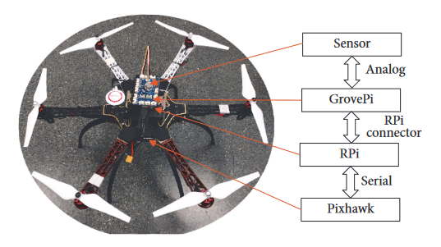

From the flow chart:

To implement a UAV controlled drone, we need to focus on two aspects:

* Hardware

Here in this project they have designed a scheme where it dynamically drives UAV by connecting a UAV control module to a Raspberry Pi, using a Grove Raspberry Hat (Groove Pi) which allows connecting different sensors easily.

